
Lab Report 09
Data Communication & Computer Networks


Submitted To:
Engineer Shehzad Malik
Submitted By:
Sumama Rahim
F24BSCS039
BS CS (F24-A-Morning)
Date: 12/13/2025
LAB REPORT – 09
Cisco Packet Tracer – Switches

Problem:
Make 3 pcs and 1 switch topology.
Solution:
Required Resources:
- 3 PCs
- 1 Switch
- Copper straight-through connection
Topology

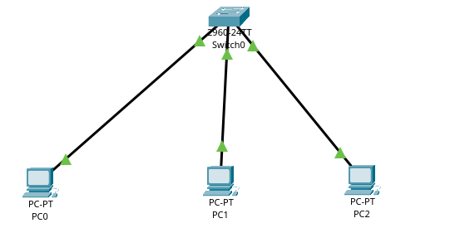
Task 1: Check number of interfaces on switch
Goto CLI (on switch)
type enable > show interfaces status

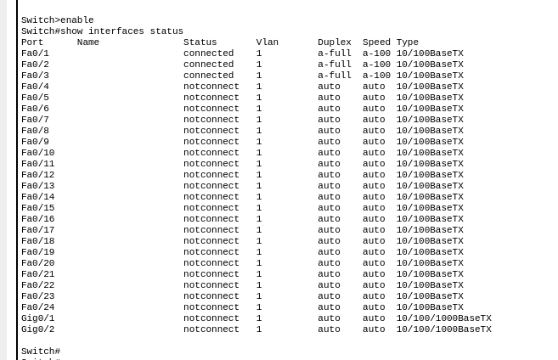
where 24 are FastEthernet and 2 are GigaEthernet interfaces so total are 26 by default.

Task 2: Checking version
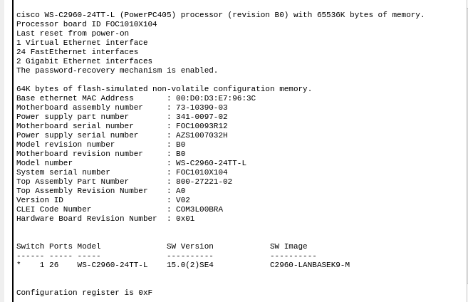
type show version in enable mode:

Task 3: Show flash memory (Switch uses flash memory which is non-volatile)

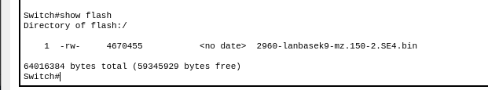
Task 4: Change host name
Same as Router

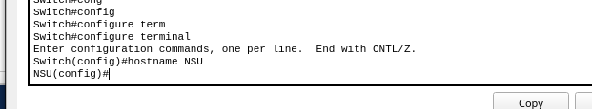
Task 5: Set line console password

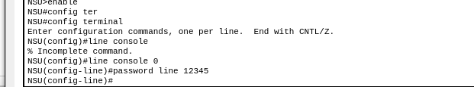
NOTE: After this step, when we restart our switch so it won’t be prompted for passwd.
Solution:

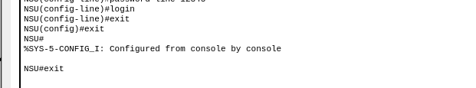
Now it would prompted for passwd.

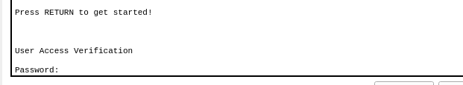
To check:
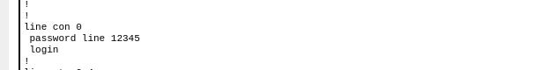

Task 6: Set passwd for privilege/enable mode

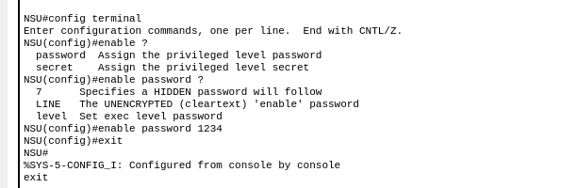
Checking:

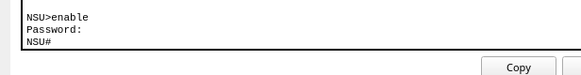
As we can see same here:
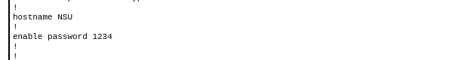

Task 7: Set/enable secret passwd

To hide passwd:
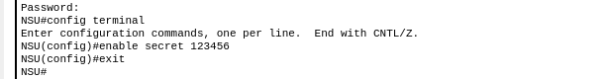
To check:

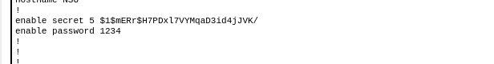

Task 8: remove all the above

Removing line console passwd:
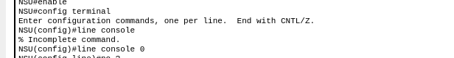
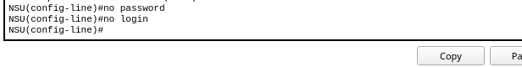
Removing secret and enable mode passwd:

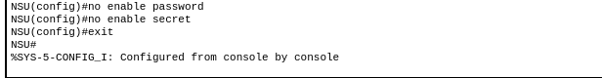

Task 9: Show MAC address table

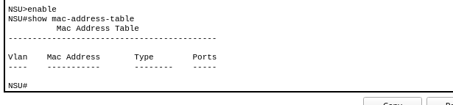
By default no MAC address is in table because we didn’t attached any PC or Printer etc.

The End

